Basic Knowledge on MS SQL Server.

Select @@version :- To know the version of SQL using query.

sp_configure:- Displays global configuration settings for the current server.

Three types of tables:

- Master table: - This table stores all Master data. Master data mean this data are fix that will not increase by any day to day transaction.

- Transaction table: - This table stores all transaction data. It means this data will increase by inserting day to day transaction. So, this table contain large records and that are not fix data.

- Mapping table: - This table maps the data between Master table and Transaction table. This table contains one or more referential key to map data..

Temp Table or Table variable or CTE are commonly used for storing data temporarily in SQL Server.

CTE
CTE stands for Common Table expressions. It was introduced with SQL Server 2005. It is a temporary result set and typically it may be a result of complex sub-query. Unlike temporary table its life is limited to the current query. It is defined by using WITH statement. CTE improves readability and ease in maintenance of complex queries and sub-queries. Always begin CTE with semicolon.

A sub query without CTE is given below :
SELECT * FROM ( SELECT Addr.Address, Emp.Name, Emp.Age From Address Addr Inner join Employee Emp on Emp.EID = Addr.EID) TempWHERE Temp.Age > 50ORDER BY Temp.NAME

By using CTE above query can be re-written as follows :
;With CTE1(Address, Name, Age)--Column names for CTE, which are optionalAS(SELECT Addr.Address, Emp.Name, Emp.Age from Address AddrINNER JOIN EMP Emp ON Emp.EID = Addr.EID)SELECT * FROM CTE1 --Using CTE WHERE CTE1.Age > 50ORDER BY CTE1.NAME

When to use CTE
1. This is used to store result of a complex sub query for further use.
2. This is also used to create a recursive query.

Temporary Tables
In SQL Server, temporary tables are created at run-time and you can do all the operations which you can do on a normal table. These tables are created inside Tempdb database. Based on the scope and behaviour temporary tables are of two types as given below-

Local Temp Table
Local temp tables are only available to the SQL Server session or connection (means single user) that created the tables. These are automatically deleted when the session that created the tables has been closed. Local temporary table name is stared with single hash ("#") sign.

CREATE TABLE #LocalTemp( UserID int, Name varchar(50),
Address varchar(150))
GO
insert into #LocalTemp values ( 1, 'Shailendra','Noida');
GO
Select * from #LocalTemp

The scope of Local temp table exists to the current session of current user means to the current query window. If you will close the current query window or open a new query window and will try to find above created temp table, it will give you the error.

Global Temp Table
Global temp tables are available to all SQL Server sessions or connections (means all the user). These can be created by any SQL Server connection user and these are automatically deleted when all the SQL Server connections have been closed. Global temporary table name is stared with double hash ("##") sign.

CREATE TABLE ##GlobalTemp( UserID int, Name varchar(50),
Address varchar(150))
GO
insert into ##GlobalTemp values ( 1, 'Shailendra','Noida');
GO
Select * from ##GlobalTemp

Global temporary tables are visible to all SQL Server connections while Local temporary tables are visible to only current SQL Server connection.

Table Variable
This acts like a variable and exists for a particular batch of query execution. It gets dropped once it comes out of batch. This is also created in the Tempdb database but not the memory. This also allows you to create primary key, identity at the time of Table variable declaration but not non-clustered index.

GO DECLARE @TProduct TABLE ( SNo INT IDENTITY(1,1), ProductID INT, Qty INT ) --Insert data to Table variable @Product INSERT INTO @TProduct(ProductID,Qty)
SELECT DISTINCT ProductID, Qty FROM ProductsSales ORDER BY ProductID ASC
--Select data Select * from @TProduct -
-Next batch GO
Select * from @TProduct --gives error in next batch

Note
  - Temp Tables are physically created in the Tempdb database. These tables act as the normal table and also can have constraints, index like normal tables.

  - CTE is a named temporary result set which is used to manipulate the complex sub-queries data. This exists for the scope of statement. This is created in memory rather than Tempdb database. You cannot create any index on CTE.

  - Table Variable acts like a variable and exists for a particular batch of query execution. It gets dropped once it comes out of batch. This is also created in the Tempdb database but not the memory.

  - There are a few differences between Temporary Tables (#tmp) and Table Variables (@tmp), although using tempdb isn't one of them,

  - As a rule of thumb, for small to medium volumes of data and simple usage scenarios you should use table variables. (This is an overly broad guideline with of course lots of exceptions - see below and following articles.)

  - Temporary Tables are real tables so you can do things like CREATE INDEXes, etc. If you have large amounts of data for which accessing by index will be faster than temporary tables are a good option.

  - Table variables can have indexes by using PRIMARY KEY or UNIQUE constraints. (If you want a non-unique index just includes the primary key column as the last column in the unique constraint. If you don't have a unique column, you can use an identity column.)

  - Table variables don't participate in transactions, logging or locking. This means they're faster as they don't require the overhead, but conversely you don't get those features. So for instance if you want to ROLLBACK midway through a procedure then table variables populated during that transaction will still be populated!

  - Temp tables might result in stored procedures being recompiled, perhaps often. Table variables will not.

  - You can create a temp table using SELECT INTO, which can be quicker to write (good for ad-hoc querying) and may allow you to deal with changing datatypes over time, since you don't need to define your temp table structure upfront.

  - You can pass table variables back from functions, enabling you to encapsulate and reuse logic much easier (eg make a function to split a string into a table of values on some arbitrary delimiter).

  - Using Table Variables within user-defined functions enables those functions to be used more widely (see CREATE FUNCTION documentation for details). If you're writing a function you should use table variables over temp tables unless there's a compelling need otherwise.

  - Both table variables and temp tables are stored in tempdb. But table variables default to the collation of the current database versus temp tables which take the default collation of tempdb (ref). This means you should be aware of collation issues if using temp tables and your db collation is different to tempdb's, causing problems if you want to compare data in the temp table with data in your database.

  - Global Temp Tables (##tmp) are another type of temp table available to all sessions and users

Three types of views:

  - System defined Views: - System defined Views are predefined Views that already exist in the Master database of Sql Server. These are also used as template Views for all newly created databases. These system Views will be automatically attached to any user defined database.
Example: - select * from sys.objects

  - Information Schema View: - In Sql Server we have twenty different schema views. These are used to display information of a database, like as tables and columns. This type of view starts with INFORMATION_SCHEMA and after this view name.
Example: - select * from INFORMATION_SCHEMA.COLUMNS

  - User Defined Views :- These types of view are defined by users.
Example: - CREATE VIEW [dbo].[UserDetails] AS
SELECT * FROM TblUser
GO
In this type of view, Insert can be use but there are some rules for it.

Procedure:-
A stored procedure is a set of one or more SQL statements that are stored together in database. To create a stored procedure use CREATE PROCEDURE statement. To use the stored procedure you send a request for it to be executed. When server receives the request, it executes the Stored procedure.

Example: - CREATE PROCEDURE usp_SelectAllUser
AS
BEGIN
SELECT * FROM TblUser
END
GO

Function:-
A user-defined function is a Transact-SQL or common language runtime (CLR) routine that accepts parameters, performs an action, such as a complex calculation, and returns the result of that action as a value. The return value can either be a scalar (single) value or a table.

Files and Filegroups Architecture

SQL Server databases have three types of files:
- Primary data files :-
The primary data file is the starting point of the database and points to the other files in the database. Every database has one primary data file. The recommended file name extension for primary data files is .mdf.
- Secondary data files :-
Secondary data files make up all the data files, other than the primary data file. Some databases may not have any secondary data files, while others have several secondary data files. The recommended file name extension for secondary data files is .ndf.
- Log files :-
Log files hold all the log information that is used to recover the database. There must be at least one log file for each database, although there can be more than one. The recommended file name extension for log files is .ldf.

How to create Logins or how to assign rights to the user?
- To create Login follow the below instruction:
- Click on server name(PCT86\SQLEXPRESS2008R2) => Security => Login
- Right click on Login and create new user and assign rights as per need.

Code Formatting:-
Whenever want to create procedure do step by step first as per following:
- The entire variable should declare at the top. So, first declare all the variables.
- If want to create any temp table then create it.
- If want to set some value in any variable then do it.
- Then do your code.
Then divide code by this clause.(Select >> From >> Where >> Group By >> having >> Order by)
Use uppercase for this clause.

Joins:-
Joins in SQL Server allows the retrieval of data records from one or more tables having some relation between them. Logical operators can also be used to drill down the number of records to get the desired output from sql join queries.

Types of Join:

- Inner join :- This join returns rows when there is at least one match in both the tables.

SELECT t1.*,t2.*
FROM Table1 t1
INNER JOIN Table2 t2 ON t1.ID = t2.ID

- Outer join: - There are three different Outer Join methods.

- Left Outer join: - This join returns all the rows from the left table in conjunction with the matching rows from the right table. If there are no columns matching in the right table, it returns NULL values.

SELECT t1.*,t2.*
FROM Table1 t1
LEFT JOIN Table2 t2 ON t1.ID = t2.ID

- Right Outer join: - This join returns all the rows from the right table in conjunction with the
matching rows from the left table. If there are no columns matching in the left table, it returns NULL values.

SELECT t1.*,t2.*
FROM Table1 t1
RIGHT JOIN Table2 t2 ON t1.ID = t2.ID

- Full Outer join: - This join combines left outer join and right outer join. It returns row from
either table when the conditions are met and returns null value when there is no match.

SELECT t1.*,t2.*
FROM Table1 t1
FULL OUTER JOIN Table2 t2 ON t1.ID = t2.ID

- Cross join: - This join is a Cartesian join that does not necessitate any condition to join. The
Result set contains records that are multiplication of record number from both the tables.

SELECT t1.*,t2.*
FROM Table1 t1
CROSS JOIN Table2 t2

- Self-join:- Instead of inner join where clause is used in Self join.

SELECT s.SalesRep, o.Amount
FROM SalesRep s, Orders o
WHERE s.id = o.id

A self-join is basically when a table is joined to itself. The way you should visualize
a self-join for a given table is by imagining that a join is performed between two
Identical copies of that table.

Example:

SELECT
e1.Name EmployeeName,
e2.name AS ManagerName
FROM
Employee e1
INNER JOIN
Employee e2 ON e1.ManagerID = e2.EmployeeID

Understanding SSIS

What is Package?
- A package is an organized collection of connections, control flow elements, data flow elements, event handlers, variables, parameters, and configurations, that you assemble using either the graphical design tools that SQL Server Integration Services provides, or build programmatically.
- The package is the unit of work that is retrieved, executed, and saved .In other words,package is an encapsulation of other tasks.
- When you first create a package, it is an empty object that does nothing. To add functionality to a package, you add a control flow and, optionally, one or more data flows to the package.
- The following diagram shows a simple package that contains a control flow with a Data Flow task, which in turn contains a data flow.

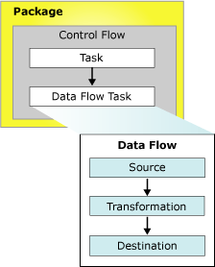
What is SSIS?

SQL Server Integration Services (SSIS) is a tool that we use to perform ETL operations; i.e. extract, transform and load data.

- E- Extract data from various homogeneous or non-homogeneous source systems. Data could be stored in any of the following forms though not limited to them: Flat file, Database, XML, Web queries etc. When we can have sources of such variety, the job of extraction is to fetch the data from these sources and make it available for the next step .

- T - Transform Data: As already discussed that the data are coming from various sources and we cannot assume that the data is structured in the same way across all the sources. Therefore, we need to transform the data to a common format so that the other transformations can be done on them.

- L Load Data: Once the transformations are done and the data takes the form as per the requirement, we have to load the data to the destination systems. The destinations can also be as varied as the sources.

Example :-

- Here is one demo on how to create simple SSIS package.The package given below reads the data from a source tab delimited text file and based on certain conditions, saves the output in two separate Excel Output Files. The output Excel files also have the same header as the input text file.

Steps to Create SSIS Package:

- Open business intelligence development studio.
- Click on File-> New -> Project.
- Select Integration service project in new project window and give the appropriate name and location for project. And click ok.

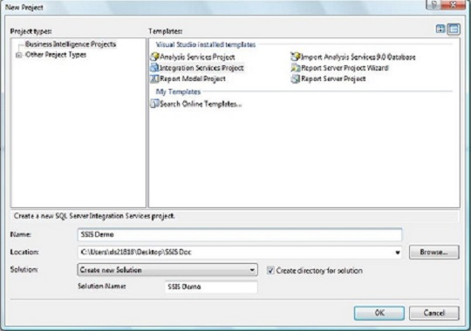

- Right click on the Connection Manager Tab, click on new FLAT File Connection Menu Item.
From that create a flat file connection manager for your source file.

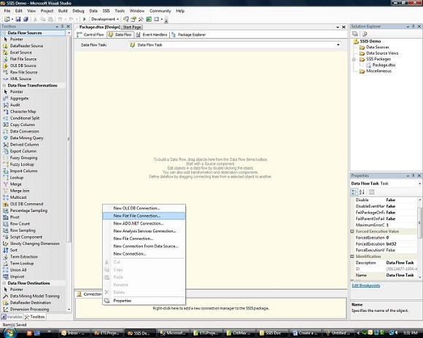

- Now Drag Data Flow Task from the Toolbox into the Control Flow Container.

- Double Click on the Data Flow Task. It will show Data flow Container tab for selected Data Flow Task. You can see three item categories in Toolbox.

  - Data flow sources - Source makes data from different external data sources available to the other components in the data flow.
  - Data flow transformations - Transformations can perform tasks such as updating, summarizing, cleaning, merging, and distributing data.
  - Data flow destinations - Destination writes the data from a data flow to a specific data store, or creates an in-memory dataset.

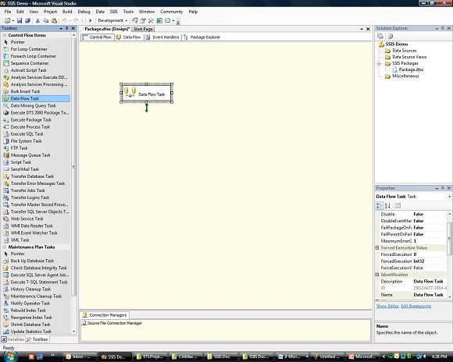

- Drag a Flat file Source Component from Data Flow Sources into Data Flow Container window.

- Double Click on the Flat File Source Component, it will display flat File source Editor then edit in that.

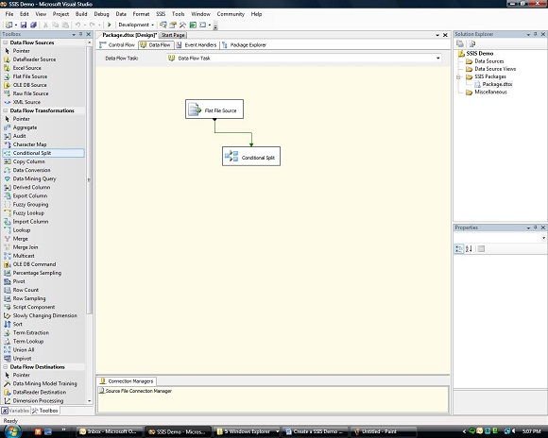
- Drag and drop a Conditional Split Component from Data Flow Transformations Tab into Data flow Task Container window. Drag and Connect the success output (which is shown by Green arrow) of Flat File Source Component to Conditional Split Component.
- Double click on the Conditional Split component, it will open Conditional Spilt Component editor window. Here user can specify the condition(s) as per the requirement and click ok. For example:
- HigherSalary: [Salary] > 20000 (Redirect records if salary is greater than 20000)
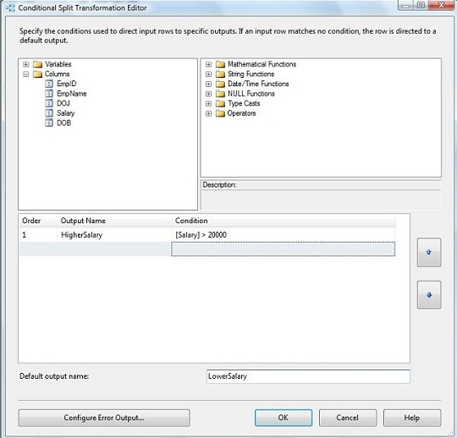
- LowerSalary: For rest of the records

- Drag and drop Excel Destination component from Data Destinations tab into Data Flow Task Container.

- Then if we connect directly to that destination then it will display error that the message “Cannot Convert between Unicode and Non-Unicode string data types”.

- To resolve this issue, we need to insert a Data Conversion Transformation Component between Conditional Split and Excel Destination Component.

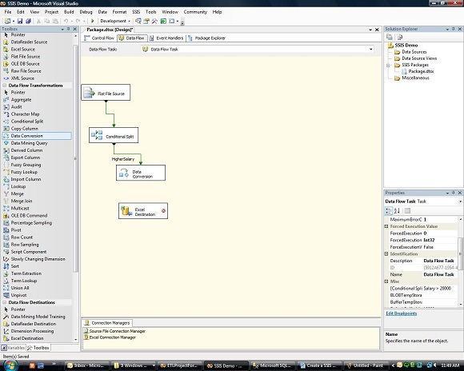

- Double Click on the Data Conversion Component, it will open Data Conversion Transformation editor. Using this component, convert input data types to required output data types.

- Click OK and connect the success arrow of Data Conversion component into Excel Destination Component. Double click on Excel Data Conversion Component and click on the mapping tab and map the output of Data Conversion Component to input of Excel Destination Component and click ok.

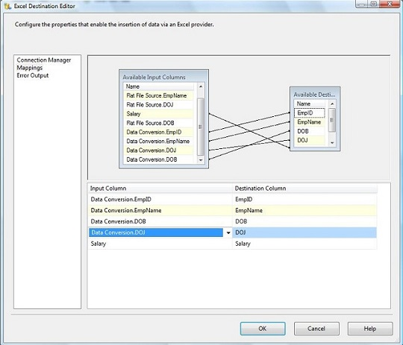

- Now add one more Data Conversion Transformation Component and connect the second success output of Conditional Split to it. Do the necessary data type conversions. Add one more Excel Destination Component and rename it .

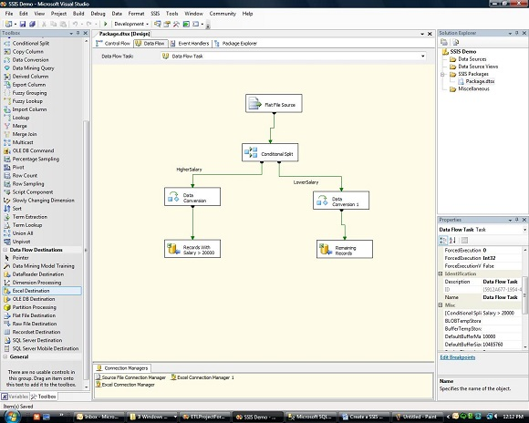

- Now the package is ready to be executed. Go to the Solution Explorer and right click on the package and select “Execute Package". If all components turn “GREEN”, it means package has run successfully, if there is any error, the component which has failed to execute will be shown in “RED” Color. We can see the package execution steps in the “Progress” tab.

- Once you run the package, data will be saved in the destination output files as per the condition specified in the Conditional Split Component.

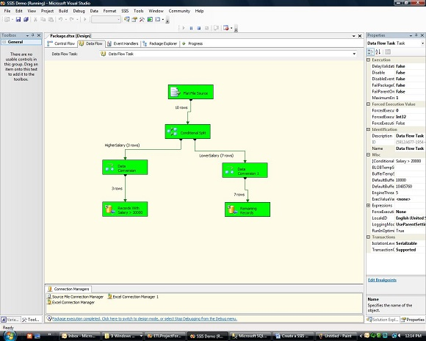

How many ways to pulling data from any file to SQL data?
- There are folling three ways :
- SSIS
- Import data in SQL
- BCP(Bulk Copy Program)

1. SSIS :- Using SSIS we can export data from any file to SQL data.
2. Import data in SQL :- Import data is an option in SQL. So, Follow the below steps to import data.
Right click Database_Name => Task => Import data

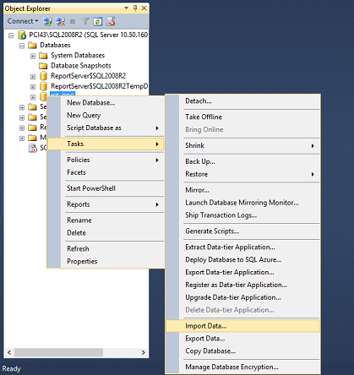
3. BCP(Bulk copy Program) Utility :- The bcp utility (Bcp.exe) is a command-line tool that uses the Bulk Copy Program (BCP) API. The bcp utility performs the following tasks:

- Bulk exports data from a SQL Server table into a data file.
- Bulk exports data from a query.
- Bulk imports data from a data file into a SQL Server table.
- Generates format files.

- Run following step in cmd
bcp [Database_Name].[Schema].[Table_Name] in/out File_Path -T
- Example:
bcp AdventureWorks2008.HumanResources.Employee out C:\Data\EmployeeData.dat -T

Row_Number() :- This one generates a new row number for every row, regardless of duplicates within a partition.
Syntax : -
ROW_NUMBER ( ) OVER ( [ PARTITION BY value_expression , ... [ n ] ] order_by_clause)

Arguments :-
- There can be two arguments in over() , that is as following :

- PARTITION BY value_expression
Divides the result set produced by the FROM clause into partitions to which the ROW_NUMBER function is applied. value_expression specifies the column by which the result set is partitioned. If PARTITION BY is not specified, the function treats all rows of the query result set as a single group.

- Order by clause
The ORDER BY clause determines the sequence in which the rows are assigned their unique ROW_NUMBER within a specified partition. It is required.

Example :

SELECT ROW_NUMBER() OVER(ORDER BY SalesYTD DESC) AS Row,
FirstName, LastName, ROUND(SalesYTD,2,1) AS "Sales YTD"
FROM Sales.vSalesPerson
Rank() :- This one generates a new row number for every distinct row, leaving gaps between groups of duplicates within a partition.
Syntax :-
RANK ( ) OVER ( [ partition_by_clause ] order_by_clause)

Arguments :- Patition by and Order by

Example :-
SELECT TOP(10) BusinessEntityID, Rate,
RANK() OVER (ORDER BY Rate DESC) AS RankBySalary
FROM EmployeePayHistory
Partition :- PARTITION BY Divides the result set into partitions. Partition by doesn't actually roll up the data. It allows you to reset something on a per group basis.

Example :-
SELECT Name,EmpId,sum(Salary)
OVER (PARTITION BY AmtPayer) AS Total
FROM dbo.Candidate

What are the rules for Union, Intersect and Except ?

- The UNION, INTERSECT, and EXCEPT set operators are used to compare and merge the results of two separate query expressions.

- UNION :- Combines the results of two or more queries into a single result set that includes all the rows that belong to all queries in the union. The UNION operation is different from using joins that combine columns from two tables.

- INTERSECT :- Set operation that returns rows that derive from two query expressions. Returns distinct rows that are output by both the left and right input queries.

- EXCEPT | MINUS :- Set operation that returns rows that derive from one of two query expressions. To qualify for the result, rows must exist in the first result table but not the second. MINUS and EXCEPT are exact synonyms.

- Rules :-
  - The number and the order of the columns must be the same in all queries.
  - The data types must be compatible.
  - The column names of the result set that are returned by EXCEPT or INTERSECT are the same names as those returned by the query on the left side of the operator.

What is the difference between VARCHAR() and NVARCHAR() ?
- NVARCHAR() stores UNICODE data. If you have requirements to store UNICODE or multilingual data, NVARCHAR() is the choice. VARCHAR() stores ASCII data .

- VARCHAR() takes 1 byte per Character and NVARCHAR() takes 2 byte per Character.

- Because of this ,VARCHAR() is better for performance.

What is the difference between CHAR() and VARCHAR() ?

- CHAR() is a fix length data type and VARCHAR() is a variable length data type.
- CHAR() :-
  - Used to store character string value of fixed length.
  - The maximum no. of characters the data type can hold is 255 characters.
  - It's 50% faster than VARCHAR.
  - Uses static memory allocation.
- VARCHAR() :-
  - Used to store variable length alphanumeric data.
  - The maximum this data type can hold is up to 4000 characters.
  - It's slower than CHAR.
  - Uses dynamic memory allocation.

Explain Drop, Delete and Truncate.

- Drop :- The DROP command removes a table from the database. All the tables' rows, indexes and privileges will also be removed. No DML triggers will be fired. The operation cannot be rolled back.

DROP TABLE employee;

- Delete :- The DELETE command is used to remove rows from a table. A WHERE clause can be used to only remove some rows. If no WHERE condition is specified, all rows will be removed. After performing a DELETE operation you need to COMMIT or ROLLBACK the transaction to make the change permanent or to undo it. Note that this operation will cause all DELETE triggers on the table to fire. And it will remove rows But it does not free the space containing the table.

DELETE FROM employee WHERE id = 100;

DELETE FROM employee;

- Truncate :- TRUNCATE removes all rows from a table and free the space containing the table. The operation cannot be rolled back and no triggers will be fired. As such, TRUCATE is faster and doesn't use as much undo space as a DELETE.

TRUNCATE TABLE employee;

Do's and Don'ts in Performance tuning.

- Try to avoid (*).
  - Example :- SELECT * FROM Employee
  - instead of this write
  - SELECT EmpId, Name, Salary FROM Employee

- Try to avoid more columns in one table. To avoid that divide them into more than one tables and give reference to it.

- Try to avoid Functions in a where clause.

- Give Proper alias to Tables and Fields.

- Try to avoid Sub queries. Use joins for that purpose.

- Use Exist and Not Exist instead of In and Not In.

- Use Union and Union All.

- Try to avoid distinct, order by.

How many Data types in SQL?

- There are following data types in SQL:

Data type | Description
char(n) | Fixed width character string. Maximum 8,000 characters
varchar(n) | Variable width character string. Maximum 8,000 characters
varchar(max) | Variable width character string. Maximum 1,073,741,824 characters
text | Variable width character string. Maximum 2GB of text data
nchar | Fixed width Unicode string. Maximum 4,000 characters
nvarchar | Variable width Unicode string. Maximum 4,000 characters
nvarchar(max) | Variable width Unicode string. Maximum 536,870,912 characters
ntext | Variable width Unicode string. Maximum 2GB of text data
bit | Allows 0, 1, or NULL
binary(n) | Fixed width binary string. Maximum 8,000 bytes
varbinary | Variable width binary string. Maximum 8,000 bytes
varbinary(max) | Variable width binary string. Maximum 2GB
image | Variable width binary string. Maximum 2GB
tinyint | Allows whole numbers from 0 to 255
smallint | Allows whole numbers between -32,768 and 32,767
int | Allows whole numbers between -2,147,483,648 and 2,147,483,647
bigint | Allows whole numbers between -9,223,372,036,854,775,808 and 9,223,372,036,854,775,807
decimal(p,s) | Allows numbers from -10^38 +1 to 10^38 –1.  The p parameter indicates the maximum total number of digits that can be stored. p must be a value from 1 to 38. Default is 18.  The s parameter indicates the maximum number of digits stored to the right of the decimal point. s must be a value from 0 to p. Default value is 0
numeric(p,s) | Same like decimal(p,s)
smallmoney | Monetary data from -214,748.3648 to 214,748.3647
money | Monetary data from -922,337,203,685,477.5808 to 922,337,203,685,477.5807
float(n) | Floating precision number data from -1.79E + 308 to 1.79E + 308.
real | Floating precision number data from -3.40E + 38 to 3.40E + 38
datetime | From January 1, 1753 to December 31, 9999 with an accuracy of 3.33 milliseconds
datetime2 | From January 1, 0001 to December 31, 9999 with an accuracy of 100 nanoseconds
smalldatetime | From January 1, 1900 to June 6, 2079 with an accuracy of 1 minute
date | Store a date only. From January 1, 0001 to December 31, 9999
time | Store a time only to an accuracy of 100 nanoseconds
datetimeoffset | The same as datetime2 with the addition of a time zone offset
timestamp | Stores a unique number that gets updated every time a row gets created or modified. The timestamp value is based upon an internal clock and does not correspond to real time. Each table may have only one timestamp variable
sql_variant | Stores up to 8,000 bytes of data of various data types, except text, ntext, and timestamp
uniqueidentifier | Stores a globally unique identifier (GUID)
xml | Stores XML formatted data. Maximum 2GB
cursor | Stores a reference to a cursor used for database operations
table | Stores a result-set for later processing

How to create User Defined Data type?

- User-defined data types can be used when several tables must store the same type of data in a column and you must ensure that these columns have exactly the same data type, length, and nullability.

- Example:-
  - CREATE TYPE udf_tableType AS TABLE
(
EmpId INT,
Name INT
)

How to export data using batch file?

- Take one simple notpad file.

- Write your code in that text file.

- Example:

  - Write following bcp code in notepad:

  - bcp "exec PRIME.dbo.RptStatusChangePayal" queryout D:\StatusReport\Report.csv -c -t, -Spct242 -Usa -Ptatva123 >D:\StatusReport\Report_log.txt

  - RptStatusChangePayal is a StoredProcedure of PRIME database in SQL.
  - D:\StatusReport\Report.csv is file where we want to export data.
  - Here we have used queryout because we want to execute one Procedure, If we want data of only one table then use out and if we want to save data in table from any file then use in.
  - Pct242 is a server name, sa is username and tatva123 is a password.
  - And D:\StatusReport\Report_log.txt is a log file.

- Then save that text file as (.bat) bat file.

- As like above example Use bcp command to export data from SQL to any file.

Indexing

- Index is a database object, which can be created on one or more columns (16 Max column combination).

- When creating the index will read the column(s) and forms a relevant data structure to minimize the number of data comparisons.

- The index will improve the performance of data retrieval and adds some overhead on data modification such as create, delete and modify.

- The whole point of having an index is to speed up search queries by essentially cutting down the number of records/rows in a table that need to be examined.

- There two type of Indexing

- Clustered Index :- The primary key created for the any column will create a clustered index for the that column. A table can have only one clustered index on it.

- Clustered Index will handle data physically by ordering data perticular column.

- When a table has a clustered index, the table is called a clustered table. If a table has no clustered index, its data rows are stored in an unordered structure called a heap.

- Non Clustered Index :- A non-clustered index is useful for columns that have some repeated values.

- Non-clustered indexes are not copies of the table but a sorting of the columns you specify .

- There are 2 modes for non-clustered indexes, Non-unique and unique.

- Non-Unique means that the index does not act as a constraint on the table and does not prevent identical rows from being inserted.

- Unique constraints mean that the index prevents any identical rows from being inserted.

- A table can have more than one Non-Clustered index. But, it should have only one clustered index that works based on the Binary tree concept. Non-Clustered column always depends on the Clustered column on the database.

- So, there are some of the disadvantages of having a database index. Well, for one thing it takes up space and the larger your table, the larger your index. Another performance hit with indexes is the fact that whenever you add, delete, or update rows in the corresponding table, the same operations will have to be done to your index. An index needs to contain the same up to the minute data as whatever is in the table column(s) that the index covers.

Index Scan:

- Since a scan touches every row in the table whether or not it qualifies, the cost is proportional to the total number of rows in the table.
- Thus, a scan is an efficient strategy if the table is small or if most of the rows qualify for the predicate.
- Index Scan is nothing but scanning on the data pages from the first page to the last page.
- If there is an index on a table, and if the query is touching a larger amount of data, which means the query is retrieving more than 50 percent or 90 percent of the data, and then optimizer would just scan all the data pages to retrieve the data rows.
- If there is no index, then you might see a Table Scan (Index Scan) in the execution plan.

Index Seek:
- Since a seek only touches rows that qualify and pages that contain these qualifying rows, the cost is proportional to the number of qualifying rows and pages rather than to the total number of rows in the table.
- Index seeks are generally preferred for the highly selective queries. What that means is that the query is just requesting a fewer number of rows or just retrieving the other 10 (some documents says 15 percent) of the rows of the table.
- In general query optimizer tries to use an Index Seek which means that optimizer has found a useful index to retrieve recordset.
- But if it is not able to do so either because there is no index or no useful indexes on the table then SQL Server has to scan all the records that satisfy query condition.

FORCESEEK Table Hint:-
- The FORCESEEK table hint forces the query optimizer to use only an index seek operation as the access path to the data in the table or view referenced in the query.
- You can use this table hint to override the default plan chosen by the query optimizer to avoid performance issues caused by an inefficient query plan.
- For example, if a plan contains table or index scan operators, and the corresponding tables cause a high number of reads during the execution of the query, as observed in the STATISTICS IO output, forcing an index seek operation may yield better query performance.
- This is especially true when inaccurate cardinality or cost estimations cause the optimizer to favor scan operations at plan compilation time.

KEY LOOKUP :-
- A key lookup is an extra read which the query has to make in the absence of a suitable covering index.
- In the query, the number of columns involved in the select statement may exceed the number of columns in the non-clustered index and when this happens, for each row in the result set, a key lookup is performed
- A key lookup occurs when data is found in a non-clustered index, but additional data is needed from the clustered index to satisfy the query and therefore a lookup occurs. If the table does not have a clustered index then a RID Lookup occurs instead.
BEST PRACTICE

Stored Procedure
  - Upper casing T-SQL keywords and built-in functions
  - Using a proper and consistent naming scheme
I like to name my objects using {target}_{verb}. So for example, if I have a Customers table, I would have procedures such as:
dbo.Customer_Create
dbo.Customer_Update
dbo.Customer_Delete
dbo.Customer_GetList
dbo.Customer_GetDetails
NEVER name stored procedures using the sp_ prefix
  - Using the schema prefix
I always specify the schema prefix when creating stored procedures. This way I know that it will be dbo.procedure_name
This prevents the database engine from checking for an object under my schema first, and also avoids the issue where multiple plans are cached for the exact same statement/batch just because they were executed by users with different default schemas.
  - Lining up parameter names, data types, and default values
I find this much easier to read:
CREATE PROCEDURE dbo.User_Update
@CustomerID INT,
@FirstName VARCHAR(32) = NULL,
@LastName VARCHAR(32) = NULL,
@Password VARCHAR(16) = NULL,
@EmailAddress VARCHAR(320) = NULL,
@Active BIT = 1,
@LastLogin SMALLDATETIME = NULL
AS
BEGIN
...

  - Using spaces and line breaks liberally
This is a simple one, but in all comparison operators I like to see spaces between column/variable and operator. So instead of @foo int=null or where @foo>1 I would rather see @foo INT = NULL or WHERE @foo > 1.
  - Avoiding data type / function prefixes on column / parameter names
I often see prefixes like @iCustomerID, @prmInputParameter, @varLocalVariable, @strStringVariable. I realize why people do it, I just think it muddies things up. It also makes it much harder to change the data type of a column when not only do you have to change all the variable/parameter declarations but you also have to change @iVarName to @bigintVarName, etc. Otherwise the purpose of the prefixed variable name loses most of its benefit. So, just name the variable for what it is. If you have a column EmailAddress VARCHAR(320), then make your variable/parameter declaration @EmailAddress VARCHAR(320). No need to use @strEmailAddress ... if you need to find out the data type, just go to the declaration line!
  - Using lengths on parameters, even when optional
  - Listing output parameters last
  - Using BEGIN / END liberally
  - Using statement terminators
  - Using SET NOCOUNT ON
I always add SET NOCOUNT ON; as the very first line of the procedure (after BEGIN of course). This prevents DONE_IN_PROC messages from needlessly being sent back to the client after every row-affecting statement, which increases network traffic and in many cases can fool applications into believing there is an additional recordset available for consumption.
  - Using local variables
DECLARE
@foo INT = 5
,@bar INT = 6
,@x INT = -1;

  - Using table aliases
SELECT
X.column1,
X.column2,
X.column3,
X.column4,
X.column5,
H.column1,
H.column2,
H.column3,
H.column4
FROM
dbo.table_X_with_long_name AS X
INNER JOIN
dbo.table_H_with_long_name AS H
ON
X.column1 = H.column1
OR X.column2 = H.column2
OR X.column3 = H.column3
WHERE
X.column1 >= 5
AND X.column1 < 10;

  - Using consistent formatting
WITH cte AS
(
SELECT
t.col1,
t.col2,
t.col3
FROM
dbo.sometable AS t
)
SELECT
cte.col1,
cte.col2,
cte.col3,
c.col4
FROM
cte
INNER JOIN
dbo.Customers AS c
ON c.CustomerID = cte.col1
WHERE EXISTS
(
SELECT 1
FROM dbo.Orders o
WHERE o.CustomerID = c.CustomerID
)
AND c.Status = 'LIVE';

  - Using RETURN and OUTPUT appropriately

  - Using parentheses liberally around AND / OR blocks

User Defined Function

1. Use scalar UDFs in SELECT or DMLs sparingly (in predicates or select list or SET clause of UPDATE)
2. Using scalar UDFs to avoid repeating simple or even complex expressions that are easily inlineable in queries or DMLs will cause performance problems
3. Use multi-statement table-valued functions carefully. The lack of statistics means that the query optimizer often makes a guess as to the cardinality of the rows returned and plan choice can be bad
4. Using scalar UDFs in procedural code to simplify logic is better than using those in set-based statements
5. Avoid doing data access or external process activation from within UDFs since they can cause performance problems or unexpected results also depending on their usage
6. If there are built-ins available to do a particular function then use those in queries or DMLs as opposed to wrapping them in a TSQL scalar UDF

Better Database Performance

1. Store relevant and necessary information in the database instead of application structure or array.
2. Use normalized tables in the database. Small multiple tables are usually better than one large table.
3. If you use any enumerated field create look up for it in the database itself to maintain database integrity.
4. Keep primary key of lesser chars or integer. It is easier to process small width keys.
5. Store image paths or URLs in database instead of images. It has less overhead.
6. Use proper database types for the fields. If StartDate is database filed use datetime as datatypes instead of VARCHAR(20).
7. Specify column names instead of using * in SELECT statement.
8. Use LIKE clause properly. If you are looking for exact match use “=” instead.
9. Write SQL keyword in capital letters for readability purpose.
10. Using JOIN is better for performance then using sub queries or nested queries.
11. Use stored procedures. They are faster and help in maintainability as well security of the database.
12. Use comments for readability as well guidelines for next developer who comes to modify the same code. Proper documentation of application will also aid help too.
13. Proper indexing will improve the speed of operations in the database.
14. Make sure to test it any of the database programming as well administrative changes.

